

Weddings at
Trentham Parish Church

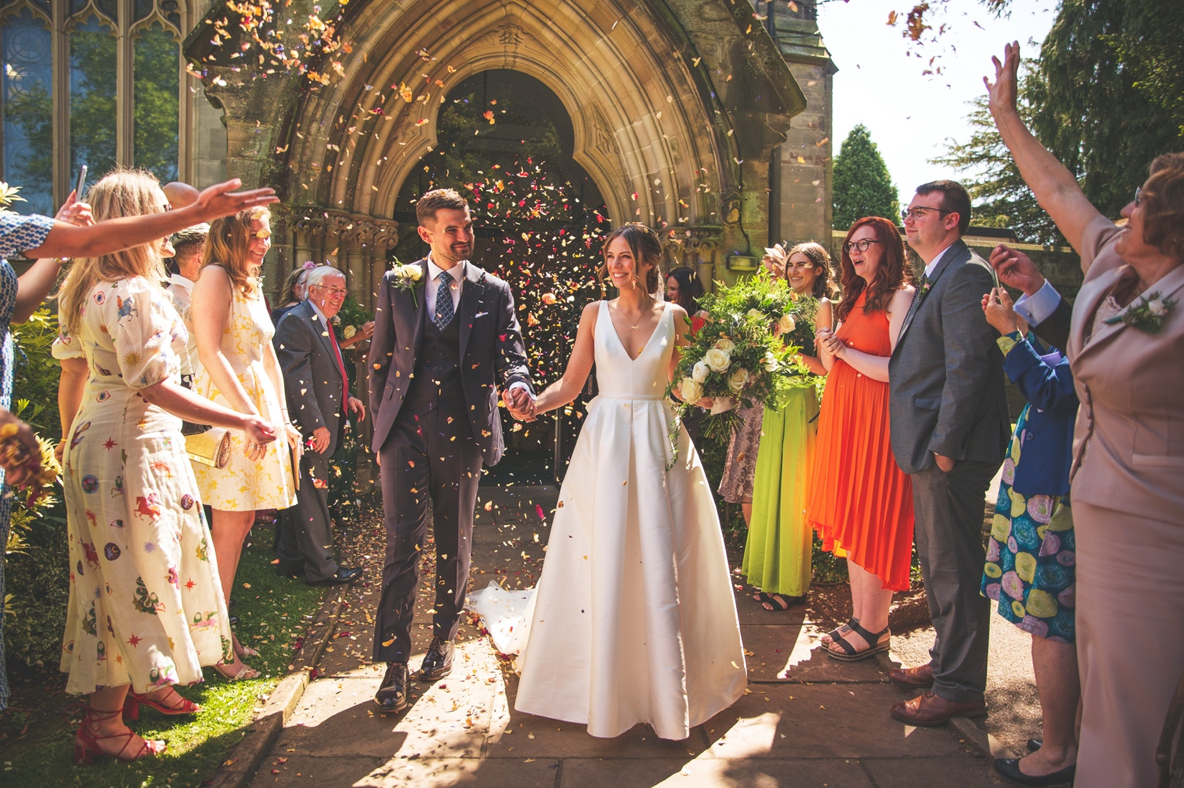

Information ahead of
your Wedding Day
Weddings at Trentham: Contents
3 - Marriage in the Church of England.
4 - Marriage Procedure
5 - Helpful Details
8 - Options to Consider
11 – Permission form for videographers
13 – Wedding Service detail form

Contact Details
Vicar - Rev. Adrian Stone – 07739043709 / adrianstonerev@gmail.com
Curate – Rev. Joe Palfreyman – 07511401304 / rev.palf@outlook.com
Church Admin (Wendy) - 01782 658110 / trenthamparishoffice@gmail.com
Website - www.trenthamparishchurch.co.uk
Address – Saint Mary & All Saints Church, Park Drive, Trentham, Stoke On Trent, ST4 8AB.

Weddings at Trentham: Helpful Information
Thank you for arranging your wedding at Trentham Parish Church. This booklet is intended to give you some helpful information. Please feel free to keep it for future reference.

Christian Marriage in the Church of England

The marriage service begins with a summary of what Christians believe marriage is for
and three important reasons are given:

- Marriage is about joining our best and closest friend in a commitment of love.

- Marriage is the committed and safe place for the true intimacy of sexual unity.

- Marriage is the stable and secure environment for having and raising children.

This is the Christian ideal for marriage and no true lovers would want to take vows that implied less. The marriage ceremony is a public declaration of your love for each other and a new statement of your commitment to an ongoing relationship. It will give you a new legal status as husband and wife and a new stability within which your relationship can grow and flourish. In choosing to get married in church you are also saying that you want God to be part of your relationship.
The Bible is full of references to love, and Christians believe that the love we have for each other reflects God’s love for his people on earth. Jesus demonstrated this love most perfectly by being prepared to sacrifice himself on the cross. Christians believe that in this amazing example of unconditional love, Jesus dealt once and for all with the problems of sinfulness. Even though we are still not perfect people, He made it possible for us to have and enjoy a new relationship with God as we believe and put our trust in Him.
In our marriages we can try to follow this model by loving our partner in a self-sacrificial way, always putting their needs before your own. Including God in your marriage doesn’t mean that you will necessarily avoid the usual ups and downs, but you will know that you can look to him for help and guidance and that His love will sustain you in the years ahead.

You will also have the support and encouragement of the Christian church family to rely upon. We sincerely hope that you will keep in touch with us after your marriage.
Marriage Procedure
We take great care in our preparation, see the full procedure below.

- Admin: Please contact our Church Administrator either by email trenthamparishoffice@gmail.com or telephone 01782 658110 who will assign you a Vicar and put you in contact with them.

- Marriage Prep: Arrange to meet with your Vicar to begin marriage preparation (This usually means meeting three times over three months to go over everything to get you both ready). Please bring your passports to the first meeting or if you have no passport your birth certificate and driving licence (photo ID)

- Banns: You will receive an invitation when your Banns of Marriage will be published. Please come along to church when your Banns are being read to get to know the church family, the building and the Vicars.

- Rehearsal: After the three marriage preparation sessions with your vicar, we will arrange the wedding rehearsal where the wedding party come to church, and we run through the service together to make sure everyone is feeling as confident as possible.

Please bring the following to your rehearsal

- The Banns Certificate from another church, if applicable

- The Video license, if applicable

- Your Order of Service

- Wedding: The big day itself. The Groom and Ushers should arrive 45 minutes before the service is due to start. The Service last around 45 minutes.

Helpful details

Banns
If both of you live in the parish, then we arrange for your banns to be called at Trentham Parish Church. If, however, one of you lives in another parish, then you must arrange for the banns to be called there. This should be done not more than ten weeks and not less than five weeks prior to the wedding. When your banns have been called at the other parish, then the minister there will issue you with a banns certificate (for which there is a fee) and you must bring this when you attend the rehearsal.

Organist
If you would like to have traditional wedding music played at the start and end of the service, or hymns sung to organ music (See suggested wedding hymns below) – we will happily book one of our organists on your behalf, though this will incur additional costs (See fees below).

Professional Singer
We have an accomplished professional singer who, for an additional fee, is available to lead the singing at weddings or if a solo performance of a hymn/hymns is desired.

Photographs If you would like to have photographs taken in the grounds of Trentham Gardens we have arranged a special price with them and will cost £240, but with no restrictions as to where you can have photo’s taken. We will collect this money on their behalf. Please tell us before hand if you would like to do this so we can check if it is available on your day.
Video
If your wedding service is to be recorded by a videographer, family friend – or even someone with a mobile phone – the only licence required is the Church Copyright (which the church has), provided the service only includes live music. Permission is also required from all participants in the service (musicians, readers etc.) if their performance is to be recorded. If a recording of the service is made whilst a sound recording is being played (e.g., a CD), that sound recording is, in effect, being copied (dubbed). Therefore, the videographer or wedding couple needs to get a Limited Manufacture Licence (LML) from the PRS for Music website at
http://www.prsformusic.com/users/recordedmedia/dvdsanddigitalmedia/Pages/LimitedManufactureLicence(LM).aspx. Please bring your licence to the rehearsal

Rehearsal

The rehearsal usually takes place in the last week before the wedding. It is helpful if the Best Man, Chief Bridesmaid, and the person leading the bride into church can attend – as well as the Bride and Groom. Others are welcome as well! At the rehearsal, please check the details are correct on the marriage document as it will cost you to change any spelling etc. once it has gone to the registry office.

Marriage Document
Two witnessess as well as the bride and groom need to sign the marriage document. During the signing of the marriage document, our organist will play appropriate music, but if you would like different music, please discuss with the Vicar conducting your wedding. The marrige document is taken to Newcastle Registry Office, you will need to contact them at least 22 days after the wedding to order Marriage certificate from them as we no longer issue them. 0300 111 8001 or website https://www.staffordshirewedding.info/

Confetti
We only allow biodegradable confetti to be used and it must only be used outside of the Church building.

Printed Order of Service
Many couples choose to prepare a printed Order of Service for their special day. These are nice to have but are by no means essential. You should agree the final layout of the internal contents with the Vicar taking your service BEFORE having them printed and ensure he and the Organist are supplied with copies at the time of the rehearsal.
We also have samples order of services which you can have a look at or borrow

Guests
We recommend that guests arrive 30-45 minutes before the service is due to start, this allows time for parking, walking to the church and being seated well before the Bride arrives. Parking is available in our Church car park which is located on the left-hand side of Park Drive a little walk away from the church (see map below).

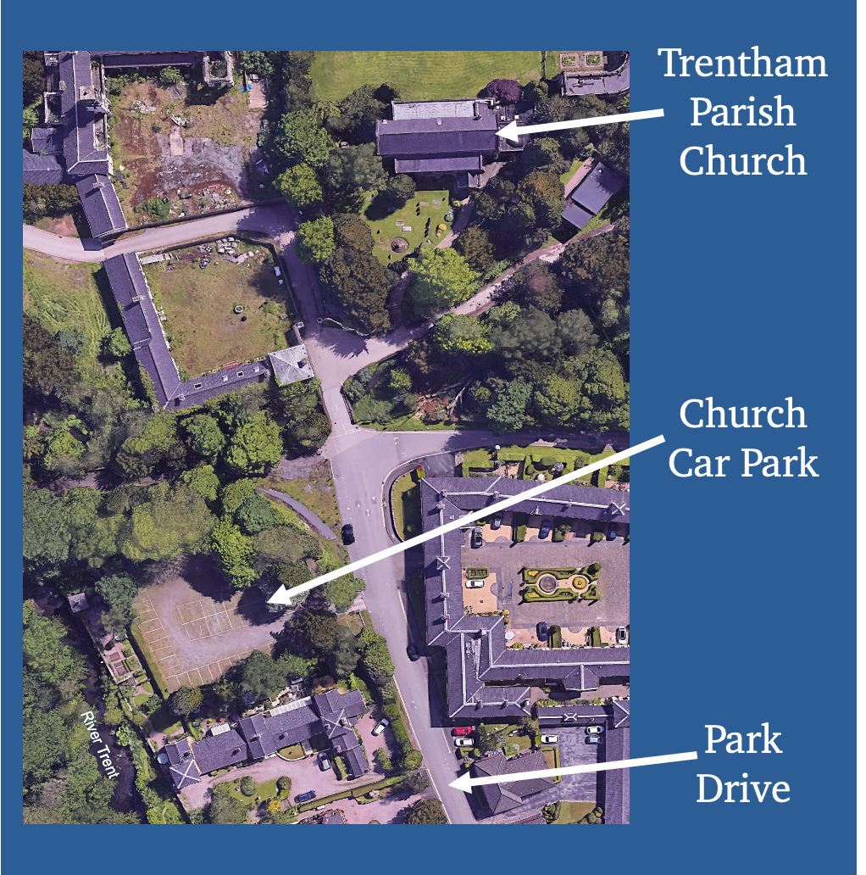

Your Wedding service
Options to consider when putting your service together

Example Order of Service

Bridal March/Music (named)
The Welcome (Rev. …….)
Hymn (print words)
Bible Reading (give reference)
Reflection
Hymn (print words)
The Marriage
The Prayers
The Blessing
Hymn (print words)
The Signing of the Marriage Document
Wedding March/Music (named)

Example Organ Music

Wagner: The Bridal March from Lohengrin
Handel: Soloman – The Arrival of the Queen of Sheba
Mendelssohn: Wedding March
JS Bach: Toccata and Fugue in D minor
Pachelbel: Canon
JS Bach: Suite No.1 – Prelude
Clarke: Trumpet Voluntary
Widor: Toccata from Symphony No. 5

Example Wedding Hymns

Love divine all loves excelling The Lord’s my Shepherd Amazing Grace
Be thou my vision
Lord of all hopefulness
Morning has broken
Lord of the dance

Now thank we all our God The King of Love my shepherd is Praise my soul, the King of heaven Lead us, heavenly Father, lead us Guide me O thou great Redeemer Great is thy Faithfulness Make me a channel of your peace

Suggested Bible Readings

Philippians 4.4-9 - Rejoice in the Lord always; again I will say, Rejoice. Let your gentleness be known to everyone. The Lord is near. Do not worry about anything, but in everything by prayer and supplication with thanksgiving let your requests be made known to God. And the peace of God, which surpasses all understanding, will guard your hearts and your minds in Christ Jesus.
Finally, beloved, whatever is true, whatever is honourable, whatever is just, whatever is pure, whatever is pleasing, whatever is commendable, if there is any excellence and if there is anything worthy of praise, think about these things. Keep on doing the things that you have learned and received and heard and seen in me, and the God of peace will be with you.

Colossians 3.12-17 - As God’s chosen ones, holy and beloved, clothe yourselves with compassion, kindness, humility, meekness, and patience. Bear with one another and, if anyone has a complaint against another, forgive each other; just as the Lord has forgiven you, so you also must forgive. Above all, clothe yourselves with love, which binds everything together in perfect harmony. And let the peace of Christ rule in your hearts, to which indeed you were called in the one body. And be thankful. Let the word of Christ dwell in you richly; teach and admonish one another in all wisdom; and with gratitude in your hearts sing psalms, hymns, and spiritual songs to God. And whatever you do, in word or deed, do everything in the name of the Lord Jesus, giving thanks to God the Father through him.

1 Corinthians 4-8a - Love is patient, love is kind. It does not envy, it does not boast, it is not proud. It is not rude, it is not self seeking, it is not easily angered, it keeps no record of wrongs. Love does not delight in evil but rejoices with the truth. It always protects, always trusts, always hopes, always perseveres. Love never fails.

Ephesians 5.21-end - Be subject to one another out of reverence for Christ. Wives, be subject to your husbands as you are to the Lord. For the husband is the head of the wife just as Christ is the head of the church, the body of which he is the Saviour. Just as the church is subject to Christ, so also wives ought to be, in everything, to their husbands. Husbands, love your wives, just as Christ loved the church and gave himself up for her, in order to make her holy by cleansing her with the washing of water by the word, so as to present the church to himself in splendour, without a spot or wrinkle or anything of the kind - yes, so that she may be holy and without blemish. In the same way, husbands should love their wives as they do their own bodies. He who loves his wife loves himself. For no one ever hates his own body, but he nourishes and tenderly cares for it, just as Christ does for the church, because we are members of his body. ‘For this reason a man will leave his father and mother and be joined to his wife, and the two will become one flesh.’ This is a great mystery, and I am applying it to Christ and the church. Each of you, however, should love his wife as himself, and a wife should respect her husband.
Ecclesiastes 4:9-12 - Two are better than one, because they have a good return for their labour: If either of them falls down, one can help the other up. But pity anyone who falls and has no one to help them up. Also, if two lie down together, they will keep warm. But how can one keep warm alone? Though one may be overpowered, two can defend themselves. A cord of three strands is not quickly broken.

1 John 4.7-12 - Beloved, let us love one another, because love is from God; everyone who loves is born of God and knows God. Whoever does not love does not know God, for God is love. God’s love was revealed among us in this way: God sent his only Son into the world so that we might live through him. In this is love, not that we loved God but that he loved us and sent his Son to be the atoning sacrifice for our sins. Beloved, since God loved us so much, we also ought to love one another. No one has ever seen God; if we love one another, God lives in us, and his love is perfected in us.

Wedding Fees for Trentham Parish Church - 2024

Wedding service in church | 531.00
Publication of Banns of Marriage | 36.00
Heating | 105.00
Organist | 115.00
Verger per person | 40.00
Admin fee | 13.00
Professional singer | 126.00
Access to Trentham Gardens for Photo’s | 240.00
Total | 1206.00

Wedding Fees for Banns at another church – 2024
Publications of Banns of Marriage | 36.00
Certificate of Banns | 18.00

All fees should please be paid in full before the wedding. Cheques should be made payable to “Trentham PCC”.
You can also pay be BACS:- Sort Code 60-21-59, Account No. 73482463, Name:- Trentham PCC.

VIDEO RECORDING OF A MARRIAGE SERVICE

Marriage between ……………………………………………………………………………… and

……………………………………………………………………………………………………………

Date …………………………………………………………………… Time ……………………….

The Vicar will allow video recording equipment to be brought into the church and used inside the church for the purpose of recording the above service subject to the following conditions which will not be varied under any circumstances.

The video recording is for private use only
- No commercial or other copying of the video recording is permitted
- The video recording in the church shall include the whole service and it will not be edited in any way
- No commentary or music shall be inserted or superimposed on any part of the video recording taken inside the church.
- The whole video recording of the service will be shot from the back of the church only. If a second camera is being used it may be sited in the Chancel by arrangement with the Vicar.
- No microphone shall be placed in any other part of the church.
- No lights other than the church lighting shall be used.
- The copyright law is strictly adhered to (see overleaf).

Permission for the use of video recording equipment in the Church will be given by the Vicar on receipt of this form (in duplicate) duly signed. Permission must be obtained at least three weeks before the date of the wedding.

We request permission to make a video recording of our wedding for private use only. We have read the conditions above and overleaf under which video recordings may be made in the church, and we agree to abide strictly by these conditions. We acknowledge that the Vicar has only given us permission to use video recording equipment inside the church subject to the conditions specified above and that he has not authorised the recording of any material or performance which may be protected by law.

Signatures:

Video Recordist:: ………………………………………………………………………………………………..

Company: ……………………………………………………………………………………………………….

Membership no of the Institute of Videography ………….………………………………………………….

Bridegroom: ……………………………………………………………………………………………………..

Bride: …………………………………………………………………………………………………………….

Permission is given subject to the above conditions:

………………………………………………….. (Vicar) Date: …………………………….

The attention of the bridal couple and of the recordist
is drawn to the following matters:

- The law of copyright is complex. It is important that it is recognized that neither the Vicar nor the Parochial Church Council has any authority to give copyright permission for the lawful reproduction of recording of any work – literary or musical – which is protected by copyright.

- Certain ‘blanket’ arrangements have been made to facilitate the recording in church of the texts of the marriage service. Without prior application having been made to the copyright owners, copyright permission has been given for the recording of authorised Church of England Marriage services, subject to the following conditions:

a) no rights in the recording and no copies of it shall be transferred or assigned in consideration of money or month’s worth, ie. the rights in the recording – and copies shall not be sold commercially except that the original recording and copies may be sold to the bridal couple who commissioned the recording.

b) no more than three copies of the recording shall be made.

c) the recording, including any extract from it, shall not be exhibited in public.

The copyright owners of the marriage services charge no fee for this permission.

- These ‘blanket’ arrangements and permissions relating to the marriage service do not extend to any part of the service other than the text of the authorised services. Thus hymns, anthems, additional prayers etc., are not covered by these permissions.

Copyright subsists in a work at least until the end of the period of 50 years from the end of the calendar year in which the originator (author, composer etc.,) died. Where there is doubt whether material is copyright protected, detailed advice is available from The Mechanical Copyright Protection Society Ltd, 41 Stratham High Road, London, SW16 1ER (tel: 0208 769 4400).

Wedding service details
Bridegroom: ………………………………………………………………………………………….

Bride: ………………………………………………………………………………………………….

Desired Wedding date: …………………………………. Desired Time: ………..………………

Best man: ……………………………………………………………………………………….………

Bridesmaids: ……………………………………………………………………………………………

Ushers: ……………………………………………….…………………………………………………

Expected attendance: …………….

Printed Order of Service: yes / no Hymn book: yes / no

Church organist: yes / no

Organ music before service …………………………………………………………………………

Bridal march: …………………………………………………………………………………………

Hymn 1:……………………………………….. Tune: …………………………………….….…

Hymn 2:……………………………………….. Tune: …………………….……….……………

Hymn 3:……………………………………….. Tune: ……………………………….….………

Wedding March: ………………………………………………………………………………………

Special musical items:………………………………………………..……………………………...

Rings: one / two

Bible reading:…………………………………… Reader: …..…………………………………...

Video: yes / no

Photographs in Trentham Gardens: yes / no

Flowers:…………………………………………………………………………………………………

Preparation evening attended: yes / no Date:………………………………….…

Final rehearsal date:………………………………………………………………………………

