

Funerals at
Trentham Parish Church
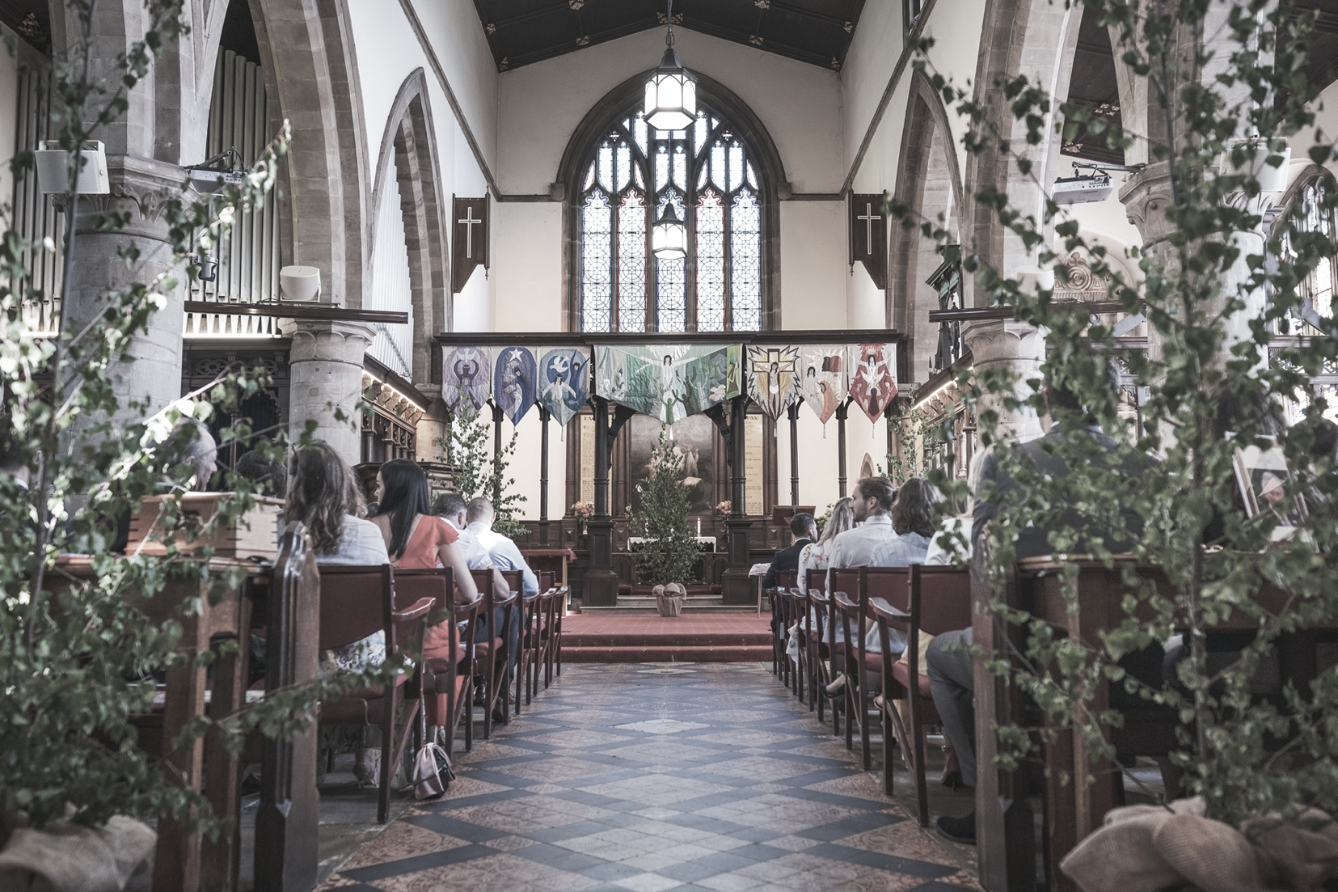
Information ahead of
a loved one’s funeral

Funerals at Trentham: Contents

3 – Funerals at Trentham Parish Church
4 - Funeral Procedure
4 - Helpful Details
6 – Funeral Fees
7 - Options to Consider
10 – Funeral Enquiry form

Contact Details
Vicar - Rev. Adrian Stone – 07739043709 / adrianstonerev@gmail.com
Curate – Rev. Joe Palfreyman – 07511401304 / rev.palf@outlook.com
Church Admin (Wendy) - 01782 658110 / trenthamparishoffice@gmail.com
Website - www.trenthamparishchurch.co.uk
Address – Saint Mary & All Saints Trentham, Stoke on Trent, ST4 8AB.

Funerals at Trentham: Helpful Information
A funeral, though a time of deep sadness and mourning, can and should be a beautiful and meaningful experience for those grieving the loss of a loved one. At Trentham Parish Church we do our utmost to work with you and the Funeral Directors to put together a funeral service that is worthy of remembrance.
Our funeral services are designed to help you
- Remember and honour those who have passed away,
- To give thanks for them
- To commend them to God
- To commit them to be buried or cremated
- To comfort one another in grief
- And ultimately, to say goodbye.

Services usually take place in Trentham Parish Church – before ending with a committal either in a local cemetery or crematorium, depending on what is desired.
If you wish for the entirety of the service to take place at the crematorium, that is also fine, your Funeral Director will organise this with the crematorium.
If you wish to do this in a different order than above, we can accommodate this. Please let your funeral director know and they will inform us when booking.
To book a funeral your chosen Funeral director will contact our church Administrator via email or phone using the details on the previous page. More details that may be useful can be found on the following pages.

Funeral Procedure
Once you have contacted your Funeral director and a date has been arranged
we will take great care in our preparation, see the full procedure below.

- Home Visit: The Vicar assigned to your service will be in touch to arrange a meeting. The purpose of this meeting is twofold, firstly to finalise the details for the service. Secondly, and most importantly, this is the Vicar’s chance to get to know you and the story of the one who has passed away.

- The Funeral: The Vicar will meet you at the church door on the day of the funeral as you follow the coffin up the church path. We will say a quick prayer, take a deep breath and then enter the church for the rest of the service. The other guests are usually already seated by this time.

Helpful Details
Church Availability
Trentham Parish Church is a busy bustling community and is sometimes unavailable. Usually, we have time for funerals on…
- Monday after 1:00pm
- Tuesday after 1.30pm
- Wednesday after 1:00pm
- Thursday all day.
We are afraid that Fridays – Sundays are unavailable for funerals unless an agreement that says otherwise is made with the Vicar on duty.

Songs, photograph montages and Videos
We have a church computer and a great sound system that mean we can play songs, and project videos or PowerPoint presentations of photographs if desired. Mention this to the Vicar when they visit if it is something you are interested in. You may need an extra verger for this.

Orders of Service
It is very helpful if you, and the Funeral Director, can ensure that the Orders of Service arrive at the church at least 30 minutes before the service is due to start. Doing so allows us to make sure all our guests receive one as they arrive.
Vergers
As well as the Vicar, the church will provide a Verger to welcome all guests and to make sure everyone has everything they need for the service. In some circumstances we may need to provide a second verger.
Guests
We recommend that guests arrive 30 minutes before the service is due to start, this allows time for parking, walking to the church and being seated well before the hearse arrives. Parking is available in the Church car park which is located on the left-hand side of Park Drive a little walk away from the church (see map below).
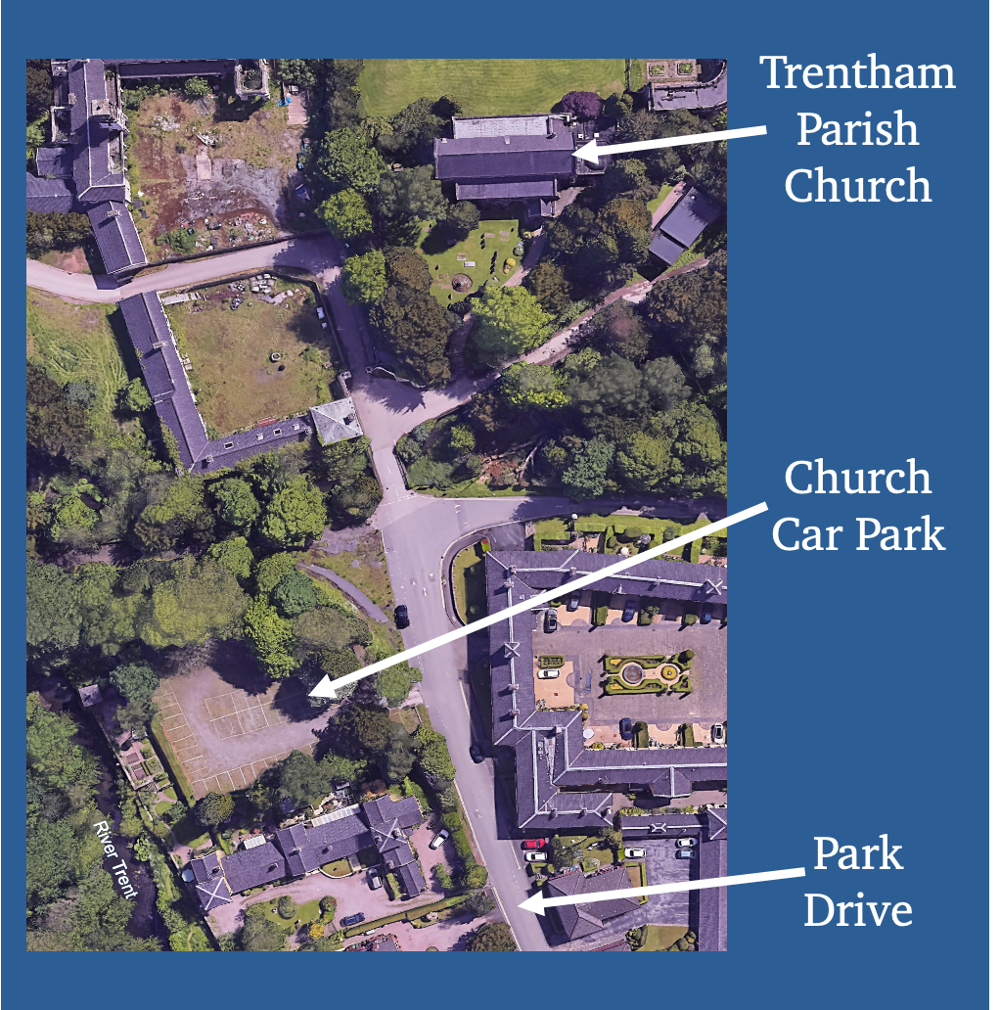

Booking an Organist

There is a fee, but our organ sounds wonderful when played by our professional musician and we have an organist we can book.

Professional Singer
We have an accomplished professional singer who, for an additional fee, is available to lead the singing at funerals or if a solo performance of a hymn/hymns is desired.

Funeral Fees for Trentham Parish Church (April 2024 – January 2025)

There is a fee for any funeral service, specific prices can be found in a table in the pages to come. All fees will be paid on your behalf by the Funeral Director

Funeral service in church | 228.00
Cremation/Burial following a service in church | 34.00
Heating (not available during Summer Months) | 105.00
Organist | 115.00
Verger per person | 40.00
Clergy Travel Expenses | 13.00
Professional Singer | 126.00
Total | 661.00

Funeral service At Cremation | 228.00
Clergy Travel Expenses | 13.00
Total | 241.00

Burial of cremated remains | 192.00
Grave digger | 60.00
Certificate of Burial If required | 18.00
Total | 270.00

BACS: NatWest
Name: Trentham PCC Account no: 73482463
Sort Code: 60-21-59
Options to Consider - Example Order of Service
At the Church (Approx. 45 minutes)
- Receiving the coffin (A Private Prayer at the church door)
- Entry - (To Organ music or a song played through our sound system).
- Welcome
- Donations: Announcement concerning your chosen charity.
- Committal & Burial: Announcement concerning the days proceedings.
- Wake details: Announcement concerning the wake to follow.
- Introduction
- Hymn / Song – (Lyrics should be included in Order of Service)
- Eulogy / Tributes / Poems
- Scripture reading: (See suggested Bible readings)
- Reflection/Sermon
- Hymn
Prayers
- The Lord’s Prayer
- The Commendation
- The Dismissal
- A Final Prayer
- Exit (To Organ music or a song).

At the Graveside / in the Crematorium (Approx. 10 minutes)
- Psalm or Bible reading
- The Committal
- The Dismissal
- A Final Prayer
- Departure

Note: The Services can be altered to a degree and there is room for flexibility and creativity. However, the final decision of what to include comes under the Vicar’s discretion with regards to appropriate content and staying on schedule with the time frame put in place by the Funeral Directors.

Suggested Bible Readings (Other suggestion are welcomed)

John 14. 1-6
Jesus said to his disciples… “Do not let your hearts be troubled. You believe in God; believe also in me. My Father’s house has many rooms; if that were not so, would I have told you that I am going there to prepare a place for you? And if I go and prepare a place for you, I will come back and take you to be with me that you also may be where I am. You know the way to the place where I am going.”
Thomas said to him, “Lord, we don’t know where you are going, so how can we know the way? Jesus answered, “I am the way and the truth and the life. No one comes to the Father except through me.
Ecclesiastes 3. 1-8
There is a time for everything,
and a season for every activity under the heavens:
a time to be born and a time to die, a time to plant and a time to uproot,
a time to kill and a time to heal, a time to tear down and a time to build,
a time to weep and a time to laugh, a time to mourn and a time to dance,
a time to scatter stones and a time to gather them,
a time to embrace and a time to refrain from embracing,
a time to search and a time to give up, a time to keep and a time to throw away,
a time to tear and a time to mend, a time to be silent and a time to speak,
a time to love and a time to hate, a time for war and a time for peace.

Psalm 23
The Lord is my shepherd, I lack nothing.
He makes me lie down in green pastures,
he leads me beside quiet waters,
he refreshes my soul.
He guides me along the right paths
for his name’s sake.
Even though I walk through the darkest valley,
I will fear no evil, for you are with me;
your rod and your staff they comfort me.
You prepare a table before me in the presence of my enemies.
You anoint my head with oil; my cup overflows.
Surely your goodness and love will follow me all the days of my life,
and I will dwell in the house of the Lord, forever.

Suggested Hymns for funerals (Other options welcomed)

- Abide with me
- Dear Lord and Father of Mankind
- Guide me, O Thou Great Redeemer
- It is well with my soul
- The Lord is my shepherd
- Amazing Grace
- Lord of The Dance
- How Great Thou Art
- Lord of All Hopefulness
- Love Divine all Love Excelling
- Make me a channel of your peace
- Morning has broken
- The Day Thou Gavest Lord has ended.

Funeral Enquiry Form
Details of the Deceased:
Name _________________________ Known as _______________________
Address________________________________________________________
__________________________________________Postcode______________
DOB ___________________Age_______ Date of Death_________

Next of Kin:
Name______________________ Relationship_______________________
Address________________________________________________
___________________________________Postcode____________
Telephone No.__________________________________________________
Email _______________________________________________________
(If there is more than one Next Of Kin please supply the details).

