

Burying Ashes at
Trentham Parish Church
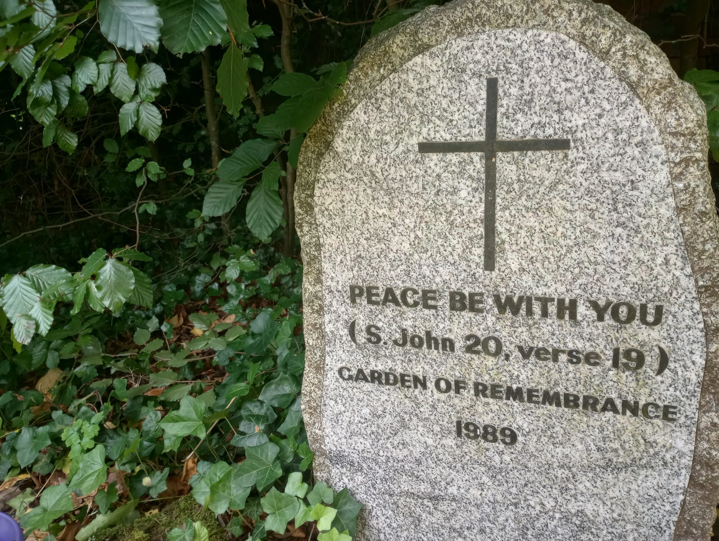

Information about our
Garden of Remembrance

Funerals at Trentham: Contents

3 – Burying Ashes at Trentham Parish Church
4 – Who can be buried & our burial procedure
5 – Garden of Remembrance Rules
6 – Clergy Availability & Fees
7 – Burial of Ashes: Inquiry Form

Contact Details
Vicar - Rev. Adrian Stone – 01782 691948 / adrianstonerev@gmail.com
Curate – Rev. Joe Palfreyman – 07511401304 / rev.palf@outlook.com
Church Admin - 01782 658110 trenthamparishoffice@gmail.com
Website - www.trenthamparishchurch.co.uk
Address – Saint Mary & All Saints Trentham, Stoke On Trent, ST4 8AB.

Burying Ashes: Helpful Information
Burying the ashes of a loved one is often the final stage of saying goodbye. Therefore, a Trentham we do our best to offer a short, reflective service in our Garden of Remembrance to honour those we love and see no more. The service itself, led by one of our Vicars, is usually about 10 minutes long and includes appropriate Psalms, readings and prayers for remembering a loved one before God and saying goodbye. After the service, the Garden of Remembrance will of course become a significant place to you and your family. Therefore, the gates to the Church grounds are always open to enable you to visit whenever you like.

Whose ashes can be buried in our Garden of Remembrance?

The right to have your ashes interred in our Garden of Remembrance following cremation relies upon a few qualifying factors.
- Parishioners: All individuals who live and therefore pass away within the parish boundaries or those whose names appear on the electoral roll of the parish church qualify for interment.
- Those outside the parish: The Vicar of the parish church has the right to give permission for those who live outside the parish to have their ashes interred though this should occur after consultation with the Churchwardens and/or the PCC.
- Faith: The right to interment cannot be refused based upon the deceased’s lack of faith in Christ nor the length of time they lived in the parish no matter how minimal.

Burial Procedure
- Contact our Church Admin on trenthamparishoffice@gmail.co.uk or call them on 01782 658110 to organise a date for the Burial of Ashes to take place.
- Our Administrator will assign you a Vicar who will contact you to discuss and confirm the details of the service.
- The Vicar will meet you in the Garden of Remembrance on the day for the service itself.

Garden of Remembrance Rules
The Garden of Remembrance is an emotionally significant and important place to many, it is also designated as Holy Ground which means there are strict rules and pieces of legislation that Trentham Parish Church must follow. This means we must enforce the following rules.
- Buried not scattered: Ashes must not be scattered or strewn in the Church grounds. Ashes must be buried at a service with a Vicar present and where an official burial plot has been assigned. Only ashes can be buried and all other items such Urns, boxes, wedding rings, letters or other personal belongings are not permitted.

- Unmarked Plots: Once the ashes are buried, each plot is to be left unmarked allowing the grass of the garden to return to full health. There is no provision for individual marker stones, vases, crosses or any artifacts that can in anyway be considered permanent. Unfortunately, this includes artificial flowers.

- Flowers: Real flowers are of course permitted and may be left within the Garden of Remembrance. Flowers will be left in place until they wither after which they will be taken by our Site Manager to be composted. Non-organic materials such as foil, string, plastic, balloons and wire are not permitted – only flowers. We can only apologise that legislation dictates that we must remove any non-organic materials as soon as they are found.

- Festival Wreathes: The only exception to the above rules is the placing of wreathes for Remembrance day, Easter and Christmas. Wreathes are permitted in the Garden of Remembrance between the following dates.

- 4th to 18th November (Remembrance Day).
- 18th to 31st December (Christmas)
- Seven days before and after Easter Sunday (Easter).

After these dates come to an end you are welcome to take the wreathes home, otherwise we are afraid they have to be removed.

Clergy Availability
Our Clergy tend to have flexible availability at the following times
- Monday 1pm onwards
- Tuesday 1.30pm onwards
- Wednesday 1pm onwards
- Thursday Anytime

Funeral Fees for Trentham Parish Church (April 2024 – 2025)

There is of course a fee for any funeral service, specific prices can be found in a table below. All fees should please be paid in full before the burial of ashes. Cheques should be made payable to “Trentham PCC”. You can also pay be BACS:- Sort Code 60-21-59, Account No. 73482463, Name:- Trentham PCC Council.
Burial of cremated remains | 192.00
Grave digger | 60.00
Certificate of Burial if required | 18.00
Total | 270.00

BACS: NatWest
Name: Trentham PCC Account no: 73482463
Sort Code: 60-21-59

Burial of Ashes Inquiry Form
Details of the Deceased:
Name _________________________ Known as _______________________
Address________________________________________________________
__________________________________________Postcode______________
DOB ___________________Age_______ Date of Death_________

Next of Kin:
Name______________________ Relationship_______________________
Address________________________________________________
___________________________________Postcode____________
Telephone No.__________________________________________________
Email _______________________________________________________
(If there is more than one Next Of Kin please supply the details).

